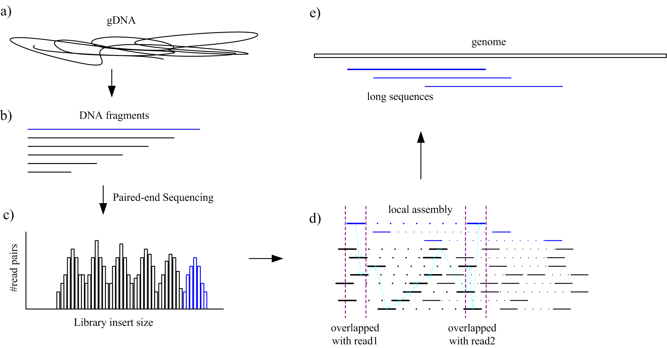
Figure 1 | A schematic overview of the sequencing and tag-free local assembly. (a) Genomics DNA was extracted from D. melanogaster. (b) gDNA was randomly sheared into a smear of DNA fragments, and separately sent to library preparation. (c) After paired-end sequencing, read pairs with continuous insert sizes were generated. (d) Virtual layout of read pairs. Long read pairs were drawn in blue, while others in black. A process of local assembly was illustrated between two vertical purple dashed lines. Read pairs with the potential to fill in internal gap were shown in blod. A serial of arrawed lines demonstrated the path of long sequence construction. (e) Long sequences randomly laid on genome as the original long read pairs.

a b
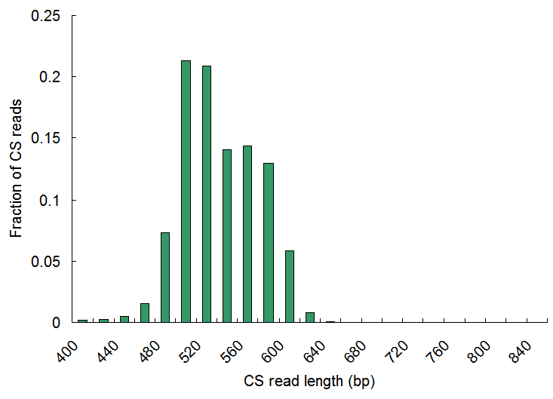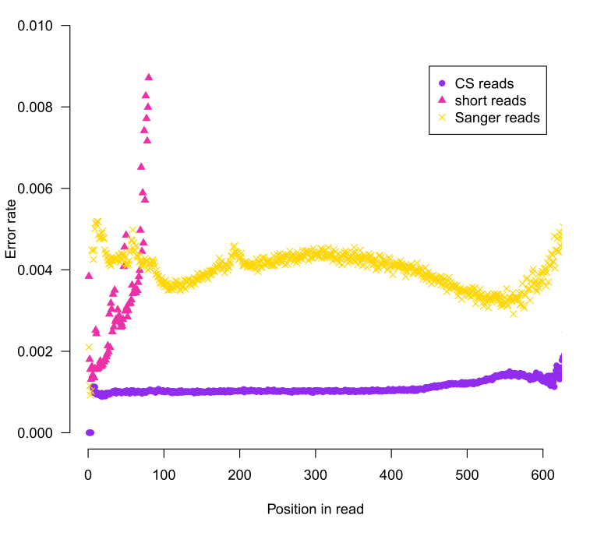
c d
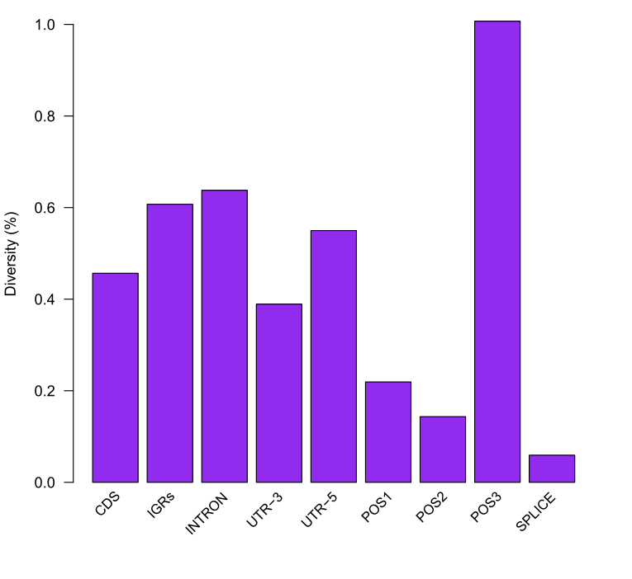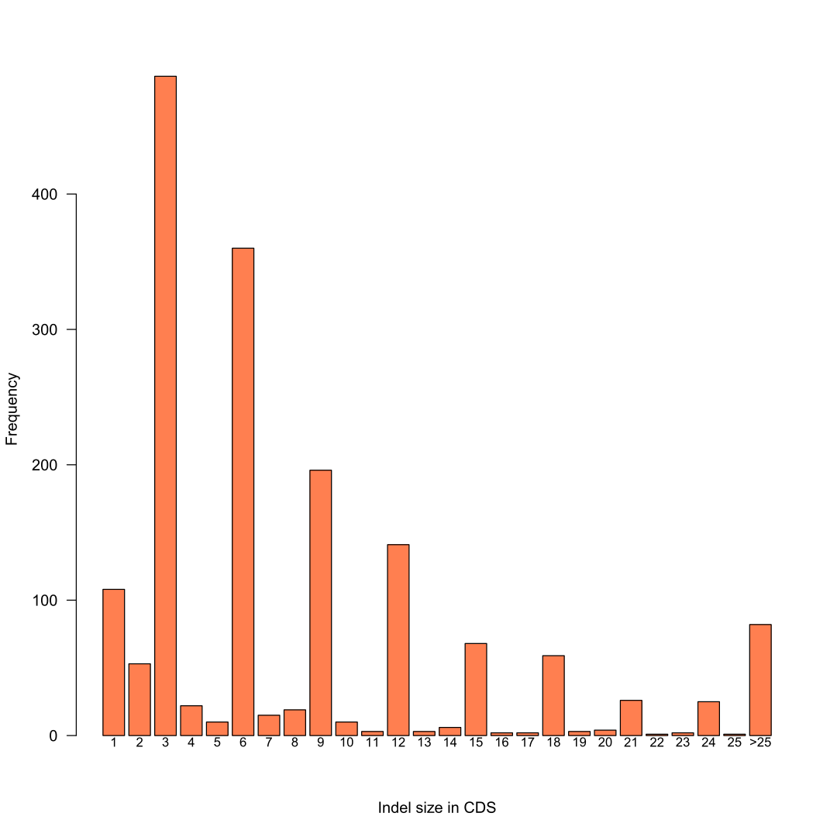
Figure 2 | Evaluation of assembled CS reads. (a) Histogram of assembled CS read length (bin size 20 bp). Noting that most CS reads are of length 500~600 bp, which is the Insert Size (IS) of SR2 library. (b) Error rate comparison as read positions among assembled CS reads, short reads and Sanger sequences. All the reads were mapped to the D.mel reference using BWA(BWASW). The overlap variants between CS reads and short reads were excluded. Read length was limited within 600 bp. (c) Diversity estimation of the sequenced w1118 line in different genomic regions after SNP analysis of CS reads. The level of diversity among those regions consists with previous data. (d) Apparent evidence for indel size of multiple three in coding sequences (CDS) after indel calling for CS reads using SAMtools.

